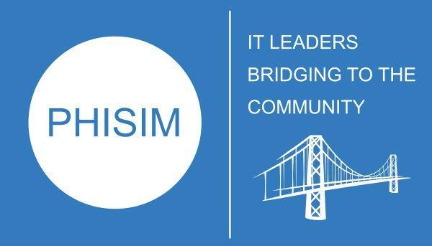 | PHILADELPHIA PHILANTHROPIC SOCIETY  FOR INFORMATION MANAGEMENT FOUNDATION INC.

I hope that you and your students are doing well and staying healthy and safe. Best wishes to you and your students for a successful new semester this spring.

At this time, PHISIM (Philadelphia Philanthropic Society for Information Management Foundation Inc.) is beginning its student scholarship process. We are pleased to once again offer this opportunity to current juniors at qualified institutions as part of our outreach to the education community in the greater Philadelphia area. Each university is required to re-qualify every three years and at this time, your university needs to resubmit the qualification form.

Attached to this email are the following documents:

- Process timeline
- Criteria for University Qualification and Application Form
We would like to ask that you complete and return the University Qualification and Application form by date. After that is received, the committee will review the application and qualified universities will be sent the student nominee form.

The student nominations will be a separate message and submission that will be due by . The scholarship recognition ceremony will be held at the Philadelphia SIM chapter meeting on Tuesday, .
If you have any questions, please do not hesitate to contact either PHISIM Board President president@phisim.org.

Thank you.
PHISIM Board of Directors
Scholarship Committee

